Title in Bold Point 14 Centered Text Times New Roman
Capitals on First Letters Only

First Author¹, Second Author², Presenting Author^{1,2}, Last Author²

¹Address and affiliation, including country
² Address and affiliation, including country

presenting.author@email.domain

Abstract main text should be written in Times New Roman point 11, justified text, with single line spacing. Paragraphs are to be separated by a blank line. Please note that 1 A4 page is an absolute maximum for all abstracts – including any graphical material and references. Pictures, diagrams and illustrations are more than welcome.

The picture (Fig. 1) below is only an example and should not be included in your abstract. References are to be given within brackets [1] [2].

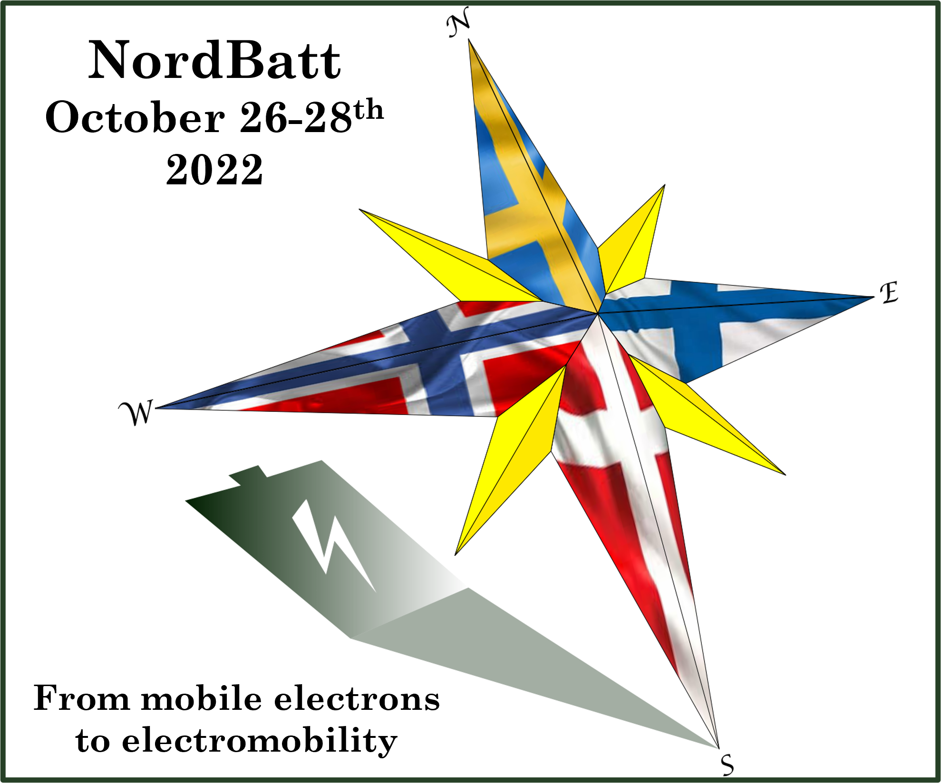

Figure 1. Figure caption is to be written in Times New Roman point 10, centered and in italics.

References

[1] F. Author, S. Colleague, Batteries & Supercaps, 1 (2022) 1-100.

[2] D. Adams, Life, the Universe and Everything, ISBN 0-345-39182-9, London, Pan Books, 1982.

